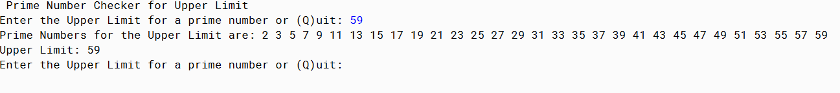

PMR: This project was more difficult since there was barley any instructions. The module in my opinion didn’t help. I had to refer to the web to finish the assignment. I was proud of my end result though.

/\*\*

\*

\* @author Anika Jallipalli

\* @date 2/18/2020

\*/

import java.util.Scanner;

public class PrimeNumbers {

public static void setup() {

System.out.println("Prime Number Checker for Upper Limit");

}

public static void menu() {

System.out.print("Enter the Upper Limit for a prime number or (Q)uit: ");

Scanner in = new Scanner(System.in);

String dataIn = in.next();

if (dataIn.equalsIgnoreCase("Q")) {

System.out.println("Goodbye.");

} else {

int uL = Integer.parseInt(dataIn);

PrimeAlgorithm pa = new PrimeAlgorithm(uL);

pa.printNumbersAndCalcForPrime();

menu();

}

}

public static void main(String[] args) {

setup();

menu();

}

}

/\*\*

\*

\* @author Anika Jallipalli

\* @date 2/18/2020

\*/

public class PrimeAlgorithm {

private static int upperLimit;

PrimeAlgorithm(int uL) {

this.upperLimit = uL;

}

public int getUpperLimit() {

return this.upperLimit;

}

public static boolean prime(int n) {

for (int i = 2; i < n; i++) {

if(n % i == 0) {

return false;

} else {

return true;

}

}

return true;

}

public static void printNumbersAndCalcForPrime() {

System.out.print("Prime Numbers for the Upper Limit are: ");

for (int i = 2; i <= upperLimit; i++) {

if(prime(i)) {

System.out.print(i + " ");

}

}

System.out.println("\nUpper Limit: " + upperLimit);

}

}